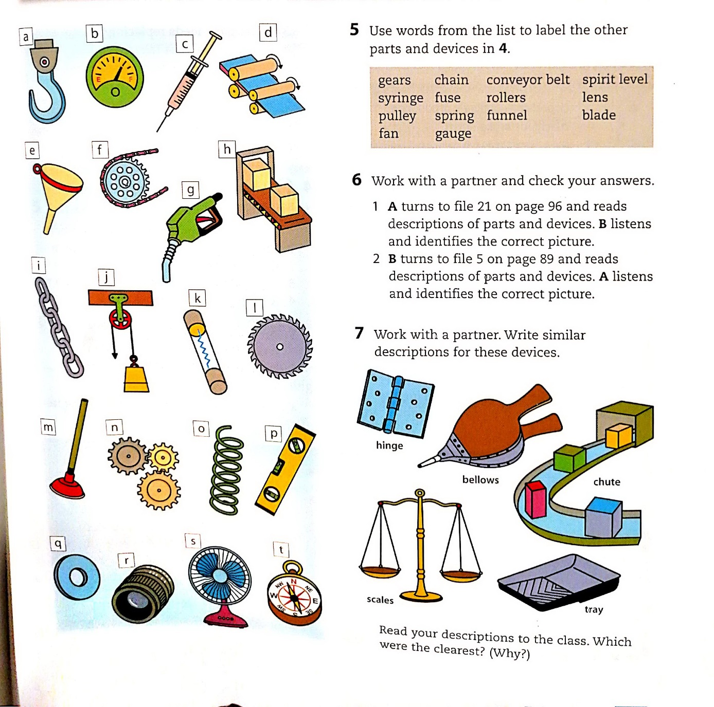
DO EXERCISE 7 -write definitions for these items!
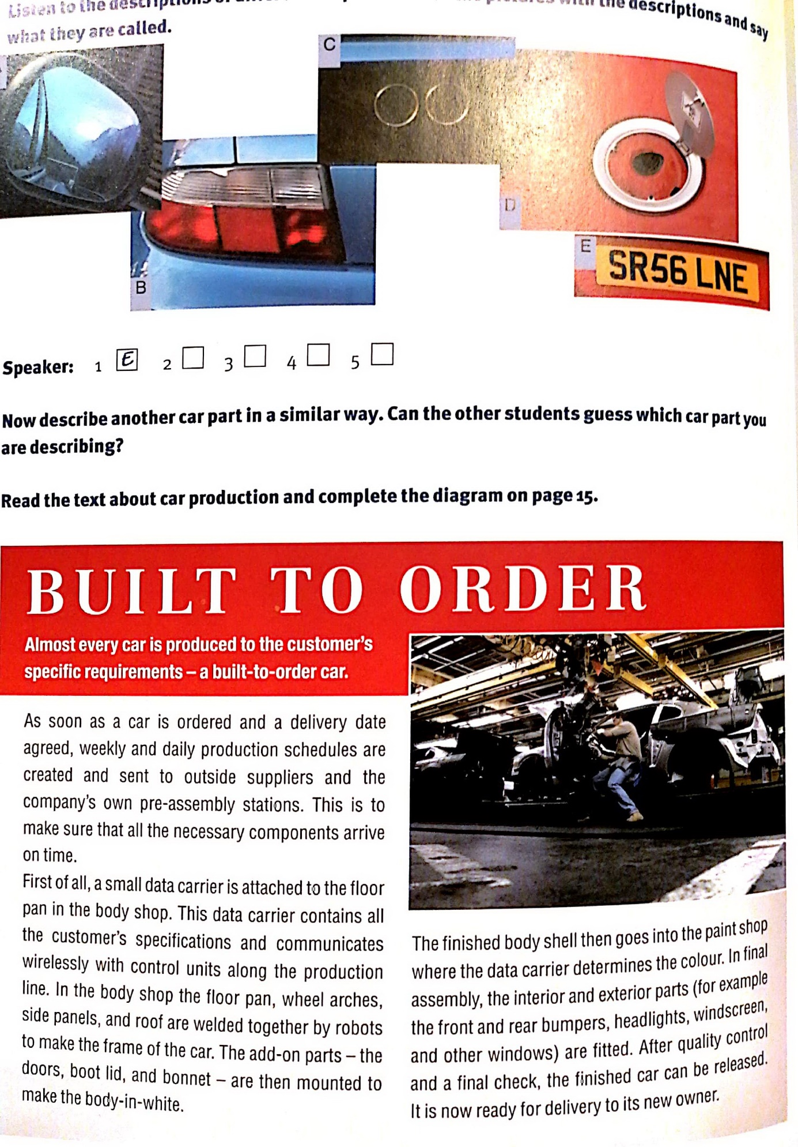
Check this link to compare the materials (text and video) https://www.youtube.com/watch?v=YVCoGlWIl4I&ab_channel=ROBSPOT
DO EXERCISE 6
